**Results**

*Trends in leaf protein abundance*

Protein abundance was strongly correlated with leaf nitrogen on a mass per area basis (Pearson’s r = 0.93), and somewhat correlated with leaf mass per area (LMA) (Pearson’s r = 0.56).

No trends in protein abundance were apparent across gradients of light availability (Fig. Xa,b), but leaf protein declined by 88 % as mean precipitation in the wettest month of the year increased from 25 to 605 mm (Fig. Xc, R2 = 0.38, p > 0.001). A somewhat weaker relationship was found with mean annual precipitation (R2 = 0.15, p > 0.001; not shown). Mean annual temperature exhibited a strong relationship with leaf protein content (Fig. Xd, R2 = 0.5, p > 0.001), and was associated with a modelled reduction protein abundance of 85 % over the measured range of 5 – 27 oC.

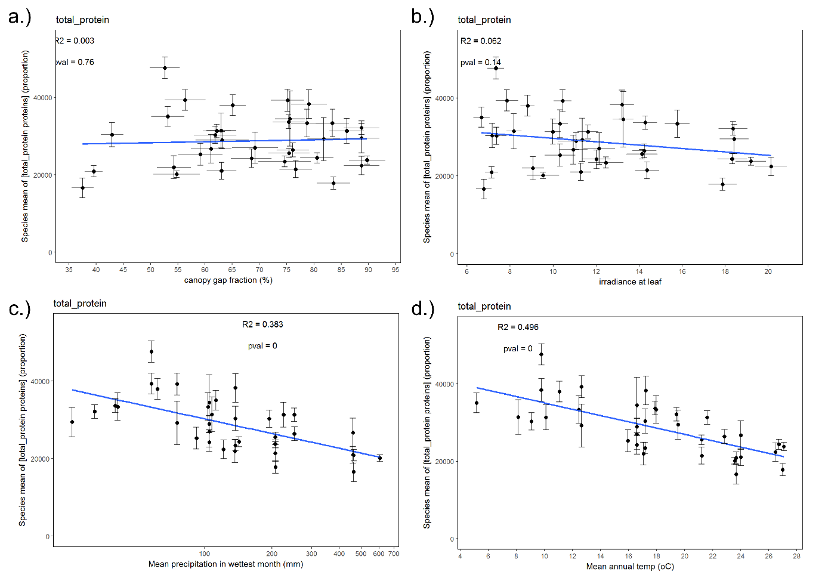

Figure X. Relationships between environmental variables and total leaf protein abundance (measured on a mass per leaf area basis): a.) canopy openness (%), b.) mean annual irradiance (MJ m-2 yr-1, corrected for progressive shading with leaf age), c.) mean precipitation in the wettest month (mm), d.) mean annual temperature (oC). Each point represents the aggregate mean associated with each species*site combination (several species were present at multiple sites and are represented more than once). Vertical error bars represent the standard error of the mean across 9 samples (3 leaf ages across 3 individuals per species). Horizontal error bars (Xa,b) show the SE of the predictor value for the species*site point. Blue lines show the fitted linear model. The axis of Xc is log10 scaled.

Variance partitioning showed that total protein abundance was not explained by temperature or precipitation independently of leaf nitrogen.

*Trends in abundance of photosynthetic light harvesting and carbon assimilation proteins across environmental gradients*

We found strong support for the hypothesis that the abundance of light harvesting proteins would be highest in light-limited environments. Photosystem protein abundance was best predicted by canopy openness (scaled by leaf age to account for self-shading) (Fig. Xa, R2 = 0.38, p < 0.001), with a modelled reduction of 54 % as the canopy opened (38 – 90 % canopy gap fraction) - approximately 1% protein per % gap fraction. Photosystem protein abundance similarly tracked mean annual radiation (again scaled by leaf age) (Fig. Xb, R2 = 0.27, p = 0.001), declining by 42 % over the observed range of 6.7 – 20.1 MJ m-2 yr-1. Photosystem abundance also increased with mean annual precipitation (Fig. Xc, R2 = 0.28, p < 0.001), which while correlated with canopy openness (Pearson’s r = 0.54) and radiation (Pearson’s r = 0.56), represents a synoptic environmental gradient of general interest. No relationship between photosystem abundance and mean annual temperature was found (Fig. Xd).

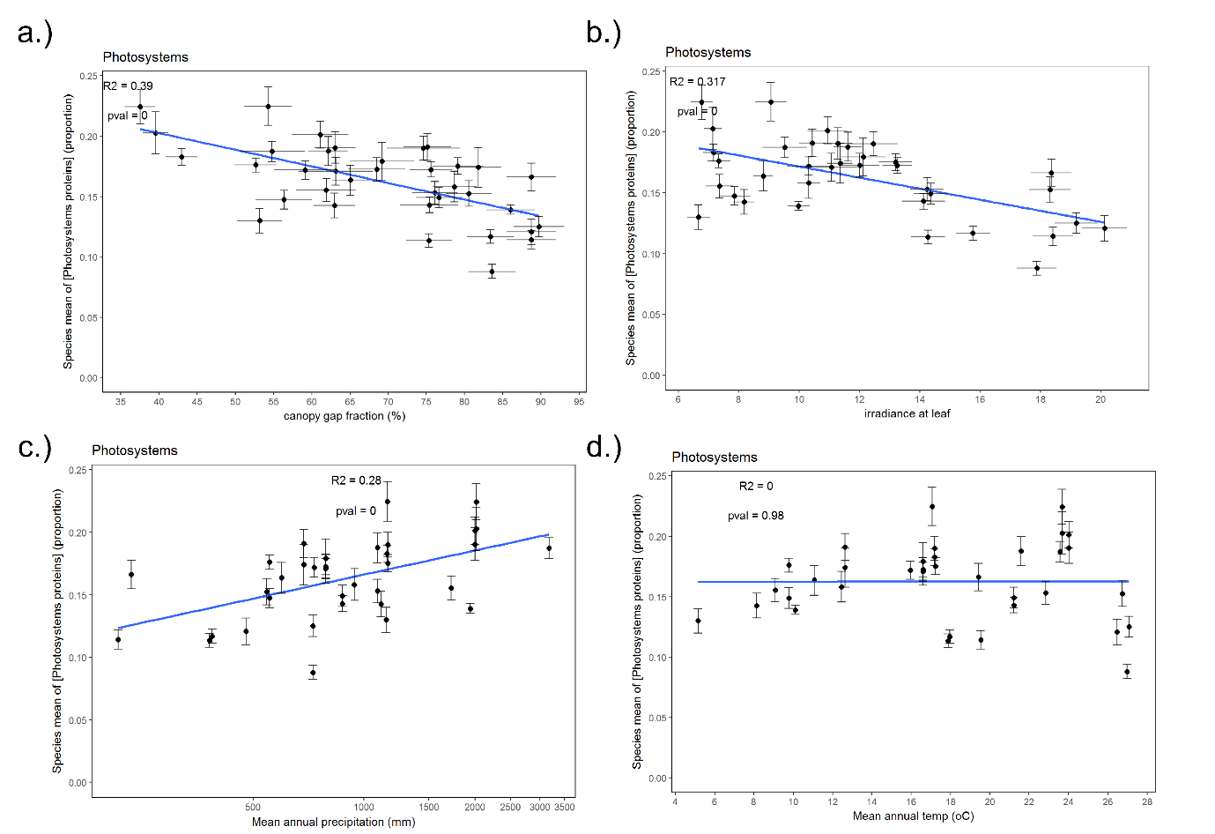

Figure X. Relationships between proportional abundances of photosystem proteins and environmental variables: a.) canopy openness (%), b.) mean annual irradiance (MJ m-2 yr-1), c.) mean annual precipitation (mm), d.) mean annual temperature (oC). Each point represents the aggregate mean associated with each species*site combination (several species were present at multiple sites and are represented more than once). Vertical error bars represent the standard error of the mean across 9 samples (3 leaf ages across 3 individuals per species). Horizontal error bars (1a,b) show the SE of the predictor value for the species*site point. Blue lines show the fitted linear model where p < 0.05. The axis of 1c is log10 scaled.

We also predicted that carbon assimilation proteins would be more abundant in high light conditions, as they determine the rate of light-saturated photosynthesis. This hypothesis was somewhat supported by a weak, shallow relationship between Calvin cycle enzyme abundance and mean annual radiation (Fig. Xb, R2 = 0.15, p = 0.020, modelled increase of 8%). Canopy gap fraction did not predict Calvin cycle enzyme abundance, however (Fig. Xa).

Calvin cycle enzyme abundance was not significantly associated with mean annual rainfall, but was inversely related to rainfall during the driest month (Fig. Xc, R2 = 0.17, p = 0.013), with a modelled decrease of 11 % across a range of 1 to 91 mm of rainfall. This relationship supports our prediction that Calvin cycle proteins will be most abundant at low rainfall sites, so as to effect greater internal [CO2] (Ci) drawdown when stomates are closed. This result should be interpreted with caution, however, in light of the wide error distribution around mean values of Calvin cycle protein abundance (see supp info). No significant relationship was found between proportional abundance of Calvin cycle enzymes and mean annual temperature (Fig. Xd, p = 0.09).

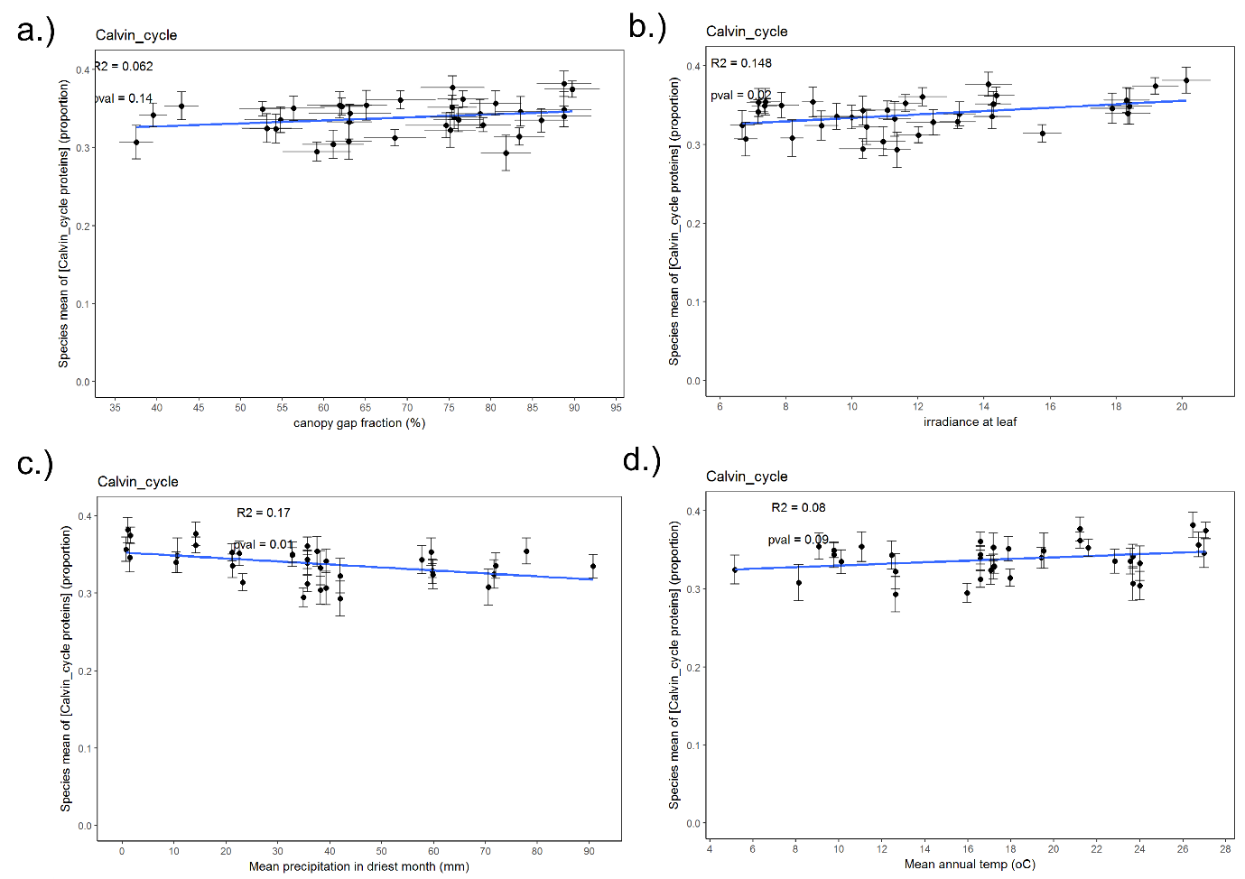

Figure X. Relationships between proportional abundances of Calvin cycle proteins and environmental variables: a.) canopy openness (%), b.) mean annual irradiance (MJ m-2 yr-1), c.) mean precipitation in the driest month of the year (mm), d.) mean annual temperature (oC). Each point represents the aggregate mean associated with each species*site combination (several species were present at multiple sites and are represented more than once). Vertical error bars represent the standard error of the mean across 9 samples (3 leaf ages across 3 individuals per species). Horizontal error bars (1a,b) show the SE of the predictor value for the species*site point. Blue lines show the fitted linear model where p < 0.05. The axis of 2c is log10 scaled.

To test hypotheses derived from the temperature-dependency of enzyme kinetics, we also tested relationships between mean annual temperature and absolute protein amounts. Absolute photosystem and Calvin cycle protein abundances both declined with increasing temperature, but no significant relationships with temperature were found in multiple regression models which accounted for declining total protein abundance with increasing temperatures.

Compared with photosystem proteins, Calvin cycle enzyme abundance was only weakly influenced by environmental conditions, in terms of both total variance explained and the magnitude of the effect. It is noteworthy that the absolute abundance of Calvin cycle enzymes is tightly bound by the total amount of leaf protein (Pearson’s r = 0.95, Fig. Xa), suggesting that Eucalypts tend to invest in carbon assimilation machinery to the maximum extent they are able. Absolute abundance of photosystem proteins also strongly tracks total protein amount, but with more room for variation (Pearson’s r = 0.82, Fig Xb). Thus the protein composition of chloroplasts appears to be most responsive to varying light environment, rather than factors which might influence Calvin cycle enzyme function such as ambient temperature or stomatal conductance.

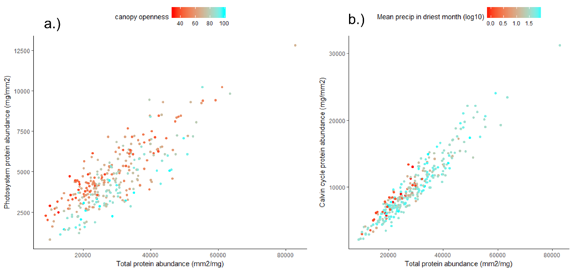

Figure X. Relationships between total protein abundance and a.) photosystems (Pearson’s r = 0.82) and b.) Calvin cycle protein abundance (Pearson’s r = 0.95). Data are not aggregated and points represent individual leaves. Colouration of the points demonstrates the effect of canopy openness (a) and mean precipitation in the driest month (b), the two strongest predictors of photosystem and Calvin cycle protein proportional abundance, respectively.

*How do protein abundances change as leaves age?*

To assess how protein abundances change with leaf age, we fitted models to unaggregated data.

Total protein differed significantly across leaf age classes (Fig. Xa): there was no significant difference between new and middle aged leaves (mean difference 3.6 %, p = 0.73), but old leaves contained considerably less protein on average than middle aged leaves (16.2 %, p = 0.002) and new leaves (13 %, p = 0.023).

We tested competing hypotheses concerning the effect of leaf age on abundance of photosynthetic proteins. In the first, we predicted that the abundance of light harvesting proteins would increase with leaf age to counter the effect of shading associated with shoot and overhead canopy development. The second hypothesis was that proportional abundance of photosynthetic proteins should decline with age, as nitrogen is progressively allocated to recalcitrant structural and defensive proteins over the lifespan of the leaf.

Light harvesting proteins increased in abundance as leaves aged (Fig. Xb): middle and old age leaves contained significantly more protein on average than new leaves (17.1 %, p > 0.001; and 24.9 %, p > 0.001) but were not significantly different from each other (mean difference 6.7 %, p = 0.11). Leaf age remained a significant predictor when canopy gap fraction was added to the model as a covariate to account for increased shading. Variance partitioning identified most variation explained in this model by leaf age as shared with gap fraction (0.09). Leaf age made only a minor independent contribution to explained variance (0.03), while gap fraction explained a larger portion independently (0.19). Thus the change in light harvesting proteins can be mostly attributed to the effect of shading.

Calvin cycle proteins were slightly more abundant (mean difference 2 %) in middle aged than old age leaves, although this difference was not significant (p = 0.58) (Fig. Xc). Old leaves contained significantly less Calvin cycle enzymes than middle leaves (mean difference 6.5 %, p = 0.003), and marginally less than new leaves (mean difference 4.7 %, p = 0.058). Calvin cycle enzyme abundance showed strong variance within leaf age classes, however, and leaf age was unable to explain a biologically meaningful proportion of variance (R2 = 0.036). As such, our data do not support hypothesis that photosynthetic proteins reduce in abundance as leaves age.

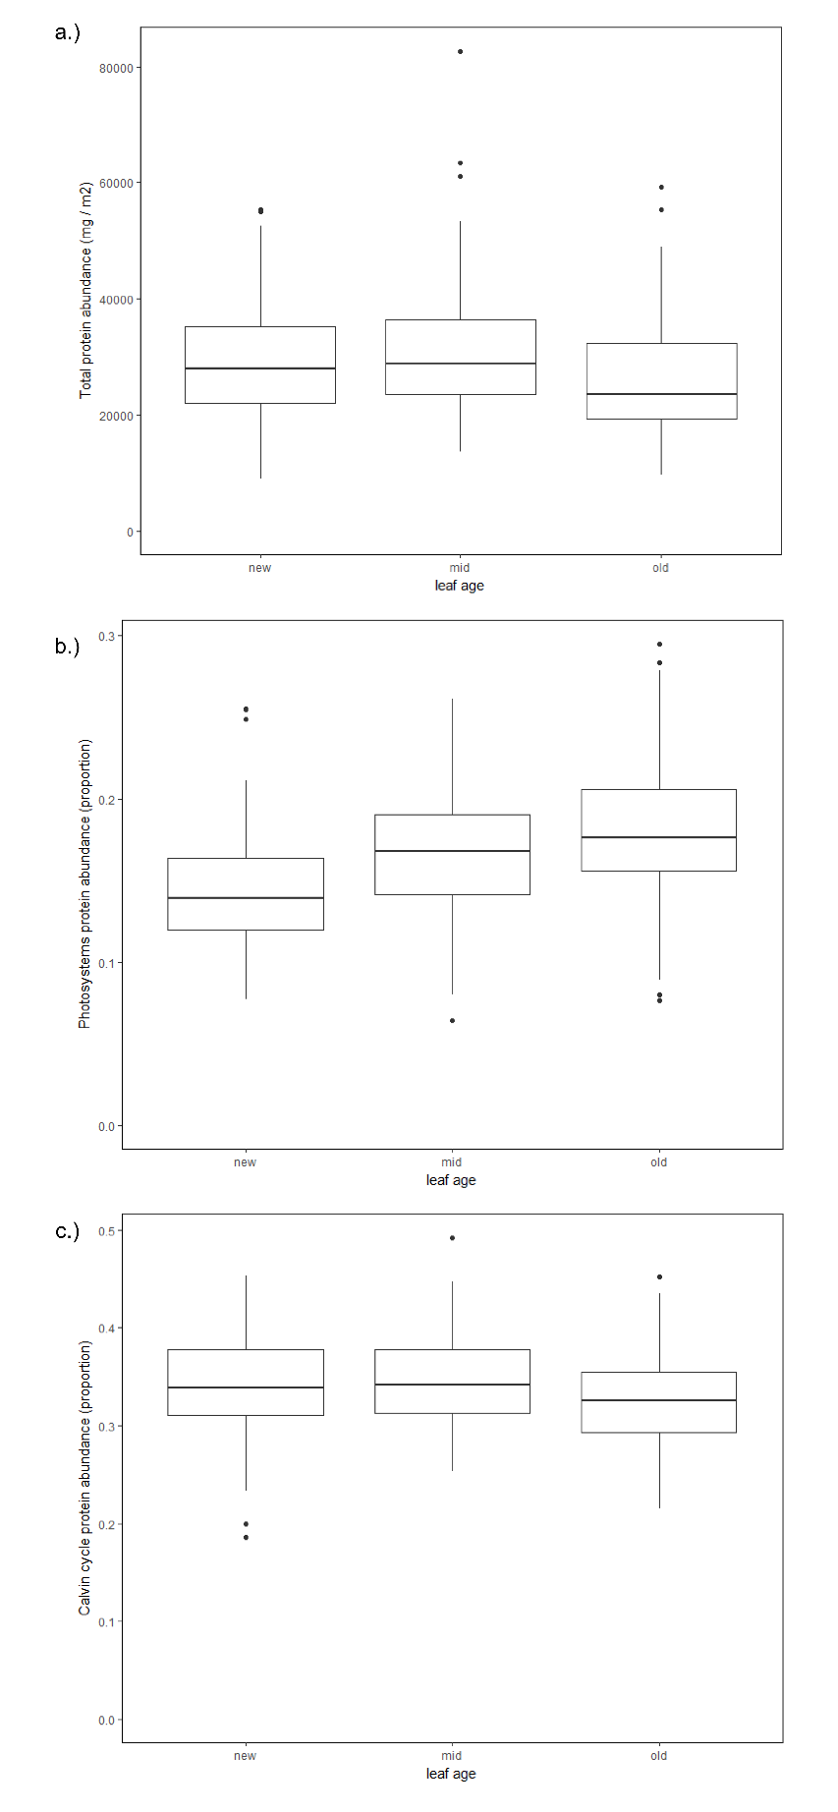

Figure 2. Boxplots of a.) total protein abundance (measured as mass per area), b.) Photosystem protein proportional abundance, c.) Calvin cycle protein proportional abundance, across leaf age classes. Lower and upper hinges correspond to the first and third quartiles; whiskers extend from the hinges to the outermost value within 1.5 times the interquartile range. Points beyond whiskers are plotted here as outliers.

**Supporting information**

*Summary statistics and fractions of variation across scales of measurement*

Our data capture a wide range of variation in protein abundance (Table 1). Variance was consistently greater between species (for a given site) than within species (Table 2). Within-site fractions of variation comprised by leaf age and biological replicate number were roughly similar within protein categories.

Table . Mean protein abundances and standard deviations (SD).

|  |  |  |
| --- | --- | --- |
|  | **Mean protein abundance (SD) (mg / m2)** | **Mean protein fraction (SD)** |
| total protein | 28651 (10678) | 1 (0.37) |
| photosystems | 4579 (1863) | 0.16 (0.07) |
| Calvin cycle | 9847 (4358) | 0.34 (0.15) |
| all photosynthesis proteins | 17348 (7013) | 0.61 (0.24) |

|  |  |  |  |
| --- | --- | --- | --- |
|  |  |  |  |
|  |  |  |  |
|  |  |  |  |
|  |  |  |  |
|  |  |  |  |
|  |  |  |  |

*Correlations between environmental variables*

|  |  |  |  |  |  |
| --- | --- | --- | --- | --- | --- |
|  | prec | pdmt | tavg | gap | irradiance |
| prec | 1 | 0.63 | 0.05 | -0.48 | -0.55 |
| pdmt | 0.63 | 1 | -0.64 | -0.36 | -0.70 |
| tavg | 0.05 | -0.64 | 1 | 0.15 | 0.56 |
| gap | -0.48 | -0.36 | 0.15 | 1 | 0.86 |
| irradiance | -0.55 | -0.70 | 0.56 | 0.86 | 1 |

